ColecoVision A/V Upgrade Kit (composite NTSC video)
Like many other consoles of the time, the ColecoVision only offered RF A/V output, with no other stock choice. Even the best RF picture from an original console can sometimes be snowy or wavy, and have poor, staticky sound.
This kit is the ultimate upgrade for your NTSC ColecoVision. You'll have crisp, clear video that is stable and sharp, no bleeding or ghosting, and crisp stereo audio.

BEFORE  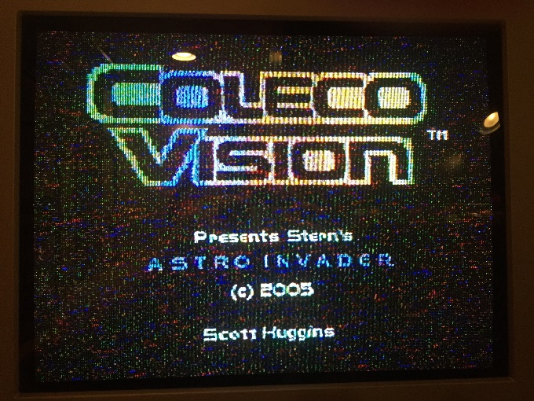 | 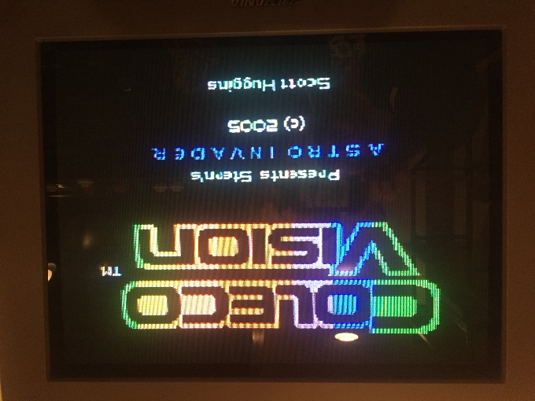  AFTER

Installation Instructions
Disclaimer: Installation of this kit involves precision drilling, trimming metal, and both soldering and desoldering. If you are uncomfortable with any of these tasks, please ask for assistance! I cannot be held responsible for any damage to the kit, your system, or yourself!
Required Tools:
- Philips screwdriver
- Soldering iron, solder
- Desoldering iron, or solder wick
- Drill, drill bits:
  - 1/16” – or similar small bit, for pilot hole
  - 1/4” – for RCA jacks
- Tin snips or other method/tool for trimming metal
- Pliers or small wrench
- Optional – Wire strippers or sharp knife
- Optional – Wire snips or scissors

Step 1:  Remove the 8 case screws.  Circled in red. | 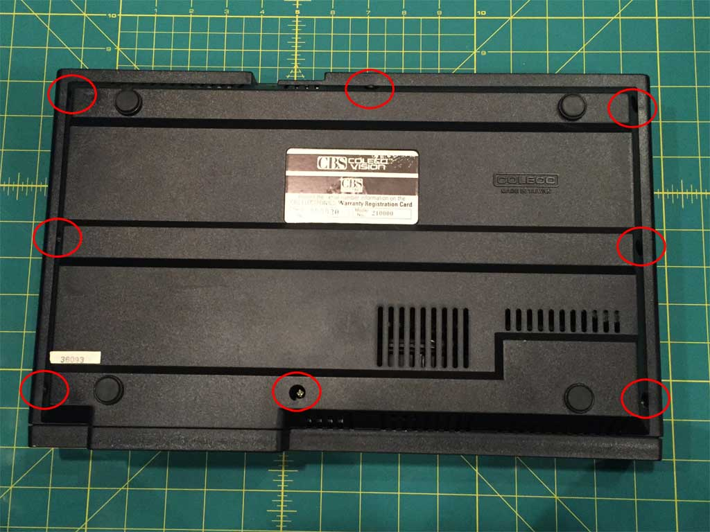

Step 2:
Open the case
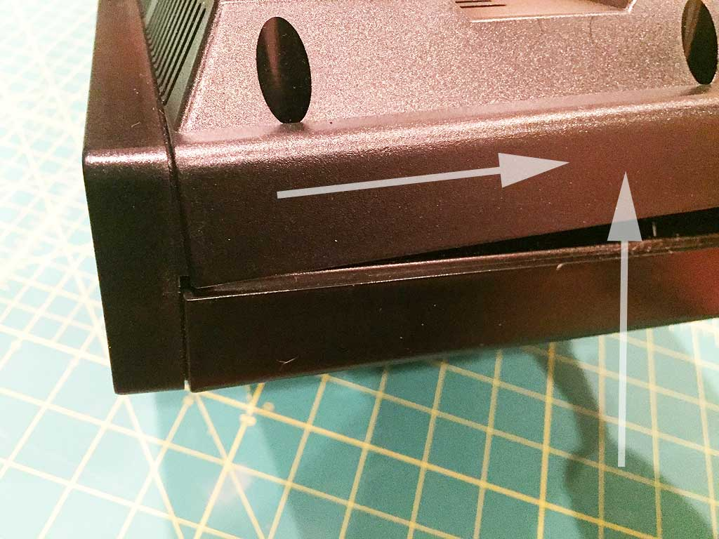 | 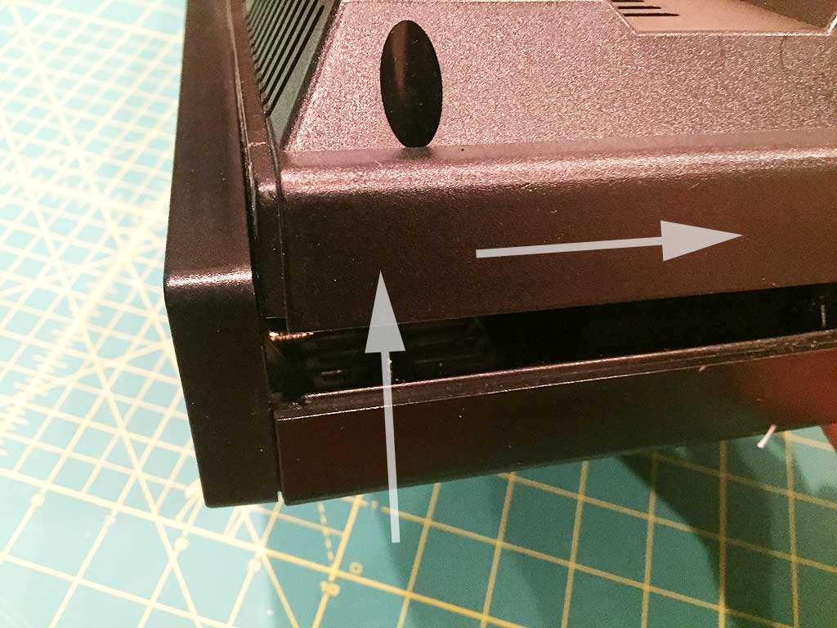
Rock the back open, then with a pulling motion, release the cover “lip” from the front bezel section. After that front lip comes loose, lift up again and continue to pull back until the case comes apart into two sections. This step can be tricky, and just takes some patience, and wiggling back and forth.

Step 3:  Remove the RF shield.  Remove the 2 screws that hold the RF shield in place. You may need to desolder the area circled in green. | 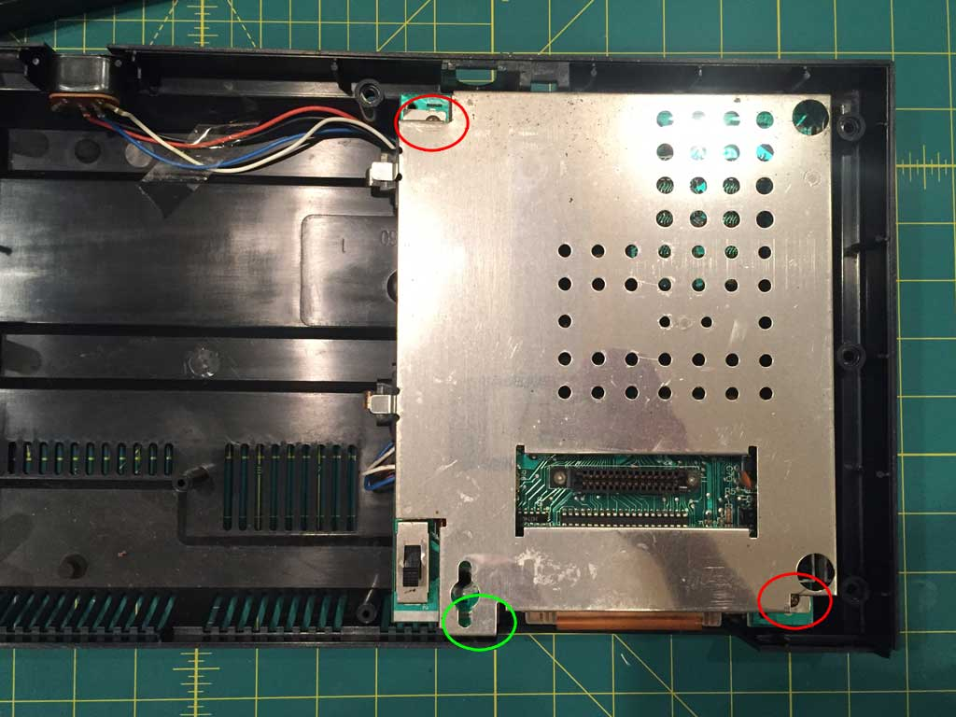

Step 4:
Remove the lid from the RF Modulator circuit.
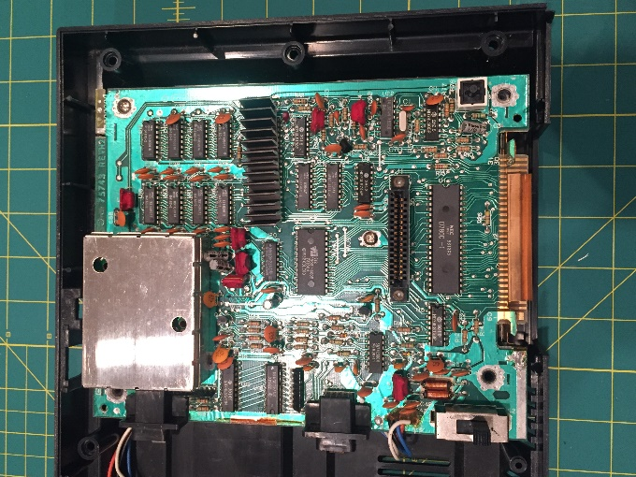 | 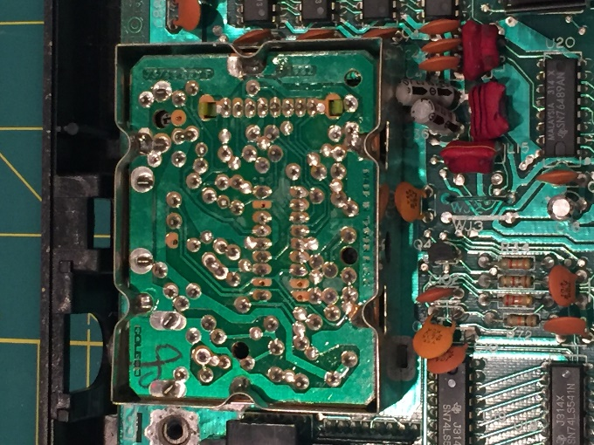
The lid should just pull right off, exposing the points you will need to solder.

Step 5:  Determine placement of the RCA jacks.  Where you put the jacks is a matter of personal preference. I also did a modification for a dual BIOS, so I left room to the left for a switch, so you may wish to do the same. I will share my setup as a starting point.  Lay down a strip of masking tape, and measure 7/32” from the top of the case, and 1-5/6” from the left edge. This provided a nicely vertically centered look for the size of the jacks, and provided enough room inside the case to work and solder.  The left edge measurement used here will give you enough room to install a toggle switch for a dual-BIOS mod.  Choose your measurements and mark the locations for the 3 jacks by marking your chosen spot for the left and right jack, then splitting the distance in half to find the location for the middle jack. The jacks in the installation shown here are a little less than 7/8” apart. | 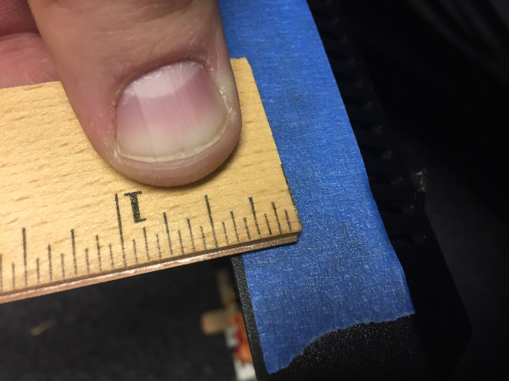

Step 6:
Drill pilot holes for the RCA jacks.
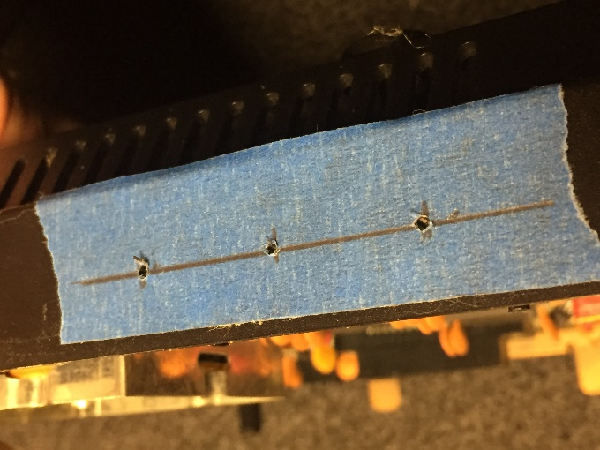 | 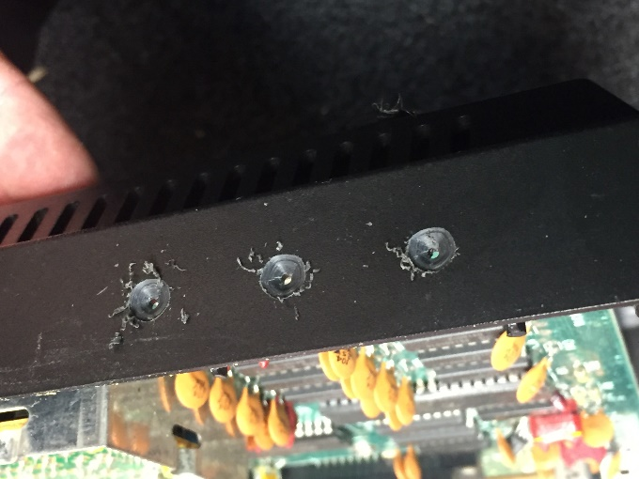
Using your marks, drill pilot holes with a small bit (1/16” recommended), checking the accuracy of your drill holes by peeling back the masking tape slightly, and fine-tuning the holes with more drilling if needed. Once the pilot holes are evenly spaced, complete the step by drilling the final hole with a 1/4” bit. Take your time, be careful and go slow!

Step 7:  Install the RCA jacks.  Using a hacksaw blade, I chose to carefully saw off one of the ribs inside the case to give myself some room to tighten the nuts, and adjust the ground rings, based on where I put the jacks. This is not necessary, and is totally optional.  ** IMPORTANT **  Orient the jack so the solder cup is facing upwards.  Complete the step by installing the three jacks, bending the prongs on the ground rings down slightly, and tightening down the nuts with pliers or a small wrench. Typically, the left audio channel is white, and the right audio channel is red. | 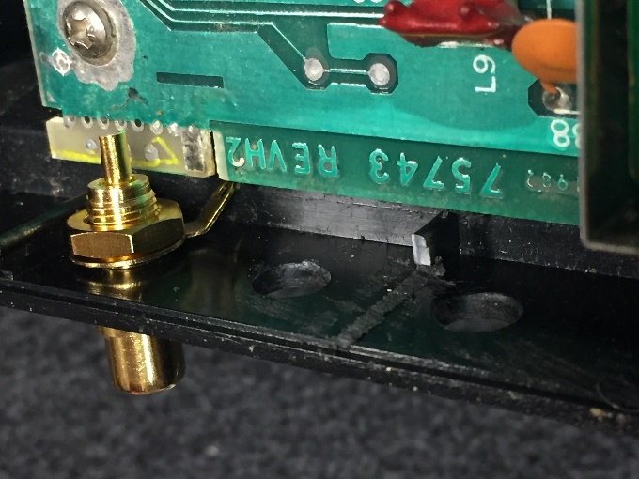
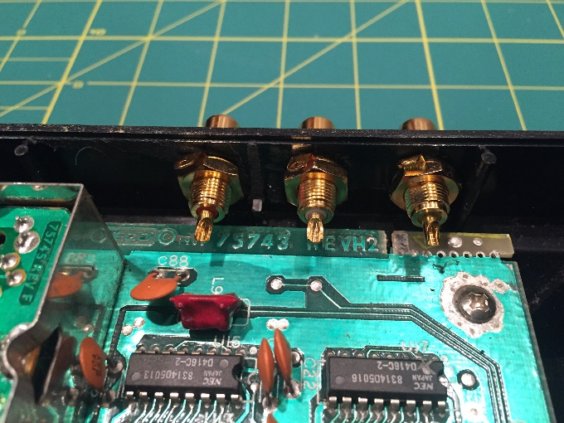 | 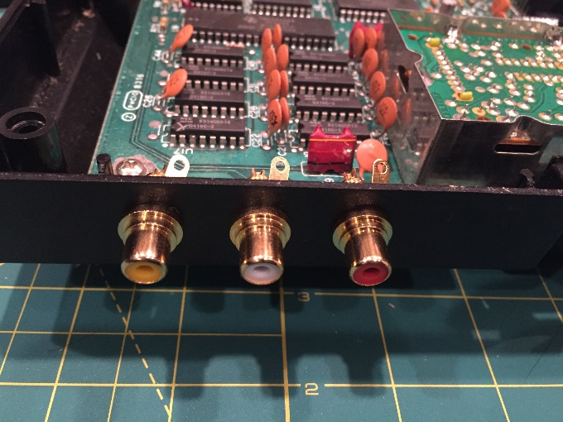

Step 8:
Install the A/V Upgrade Kit.
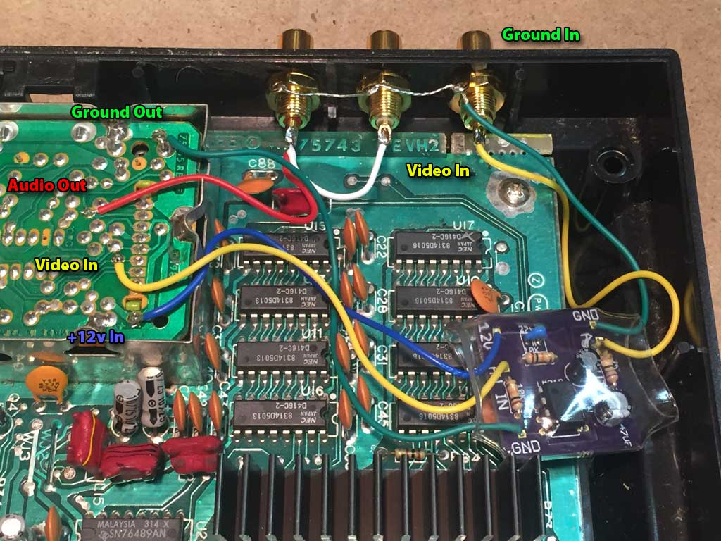
Solder the wires from the A/V Upgrade Kit into place according to the diagram. The wire ends are already stripped and pre-tinned for you, to make for a quick installation. Melt the solder at the point on the board, then quickly insert the wire at that point. The tinned wire will help greatly with making a quick connection here. If the ends needs to be trimmed slightly, use a small pair of wire cutters to shorten them to your preferred length.
The color-coded wires make installation a snap. Also, the wires out of the ColecoVision RF circuit go in to the left side of the A/V Upgrade kit PCB, and the wires coming out of the right side of the A/V Upgrade Kit PCB go out to the RCA jacks.
The loose red/white wire in the kit is for the audio connection, which does not attach to the A/V Upgrade Kit PCB at all. The wire goes directly to the left and right audio jacks. Connect the red wire to the right channel jack (red), and jump the short white wire over to the left channel jack (white).
When soldering the wires to the RCA jacks, insert the wire into the solder cup, then fill the cup with solder.
For the Ground In connection, the long section of bare wire threads through all 3 holes of the tabs on the ground rings. Depending on the spacing of your installed jacks, more stripped wire may be necessary to reach all 3 tabs. Use a wire stripper or knife to remove more insulation as necessary. Once the bare wire reaches through all 3 holes, secure the connection by soldering the wire onto each tab. Snip off any excess wire if necessary.
Since the PCB is heat shrink wrapped, it can safely sit loose inside the case; no messy tapes or glue is required to hold it into any particular place. However it is up to you if you wish to do that.

Step 9:  Trim metal shielding and replace.  Using tin snips, make two small cuts in the right side of the RF modulator box. Grab the piece (with pliers or the snips) and rock it back and forth until it snaps off, creating a channel for the wires to go through. Do this below and above the rounded notch that holds the RF modulator board in place. The notches can be seen in the photo on the previous page. Replace the RF modulator cover. This step can be optional if you want to leave off the RF modulator cover.  Now trim the RF shield that goes over the ColecoVision board. I trimmed the entire back section off, but you can trim less off if you like. You will need to trim at least enough to create room for the RCA jacks.  Replace the RF shield and secure with the 2 screws you removed in Step 3. | 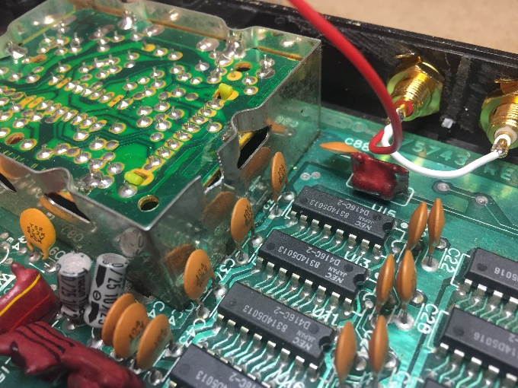
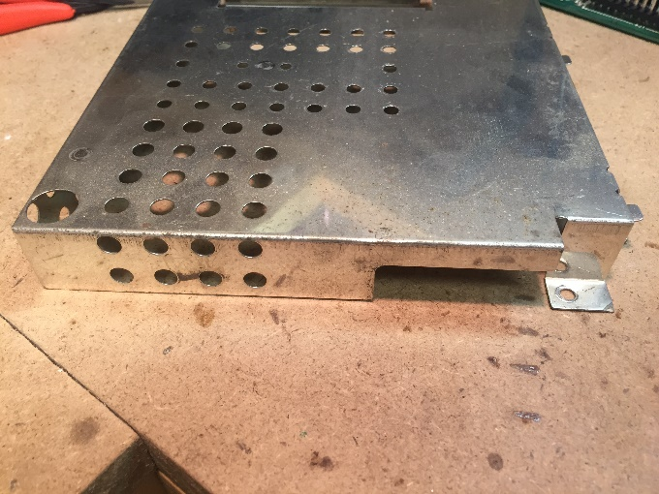 | 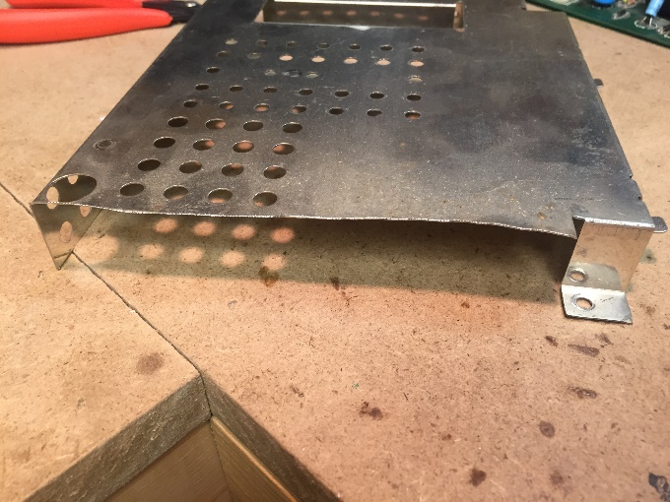

Step 10:
Test and reassemble the case.
It’s wise to check the functionality before completely assembling the stubborn case top. Just be careful and make sure nothing is shorted before plugging it in.
Other thoughts while you have the case apart:
- Clean the case top with soapy water, and thoroughly dry with canned air, or an air compressor.
- Clean the cartridge port with alcohol and a toothbrush, or a quick-dry electronic cleaner.
- If you have glitchy audio/video garbage on start-up, cleaning the power switch may help: (http://files.stardustarcade.com/Consoles/Colecovision/CV%20power%20switch%20fix.pdf)
After testing, reassemble the case top by following steps 1 and 2 in reverse. It should snap together much easier than it came off.

That’s it, you’re done! Game on…

